**Superstore Sales Analysis**

**A Simple Business Story**

Let’s imagine we are working with data from a big retail store — like a Superstore. This store sells different products across the U.S., and our job is to understand how the business is doing using data: where the company is making profit, where it's losing money, which products are doing well, and what kind of customers are buying.

Here’s the story we found from the data.

Let’s imagine we are looking at how much discount is being given on different types of products in a store. The three main product categories are **Office Supplies**, **Furniture**, and **Technology**.

From the chart, we can see that:

* **Office Supplies** receive the **highest amount of discounts**. This means customers are getting more price reductions when buying items like pens, paper, folders, and other office-related products. It could be a strategy to boost sales in this category or clear out stock.
* **Furniture** items have a **moderate level of discount**. These include chairs, desks, and storage units. Discounts are given, but not as much as office supplies.
* **Technology** products like laptops, phones, and accessories get the **least amount of discounts**. This might be because these items are already in demand or have higher value, so there’s no need to offer big discounts.

**What this tells us:**

* The company might be focusing on attracting customers with big discounts on office items.
* They are a bit more careful with discounts in the furniture and especially technology categories, possibly to protect profit margins.

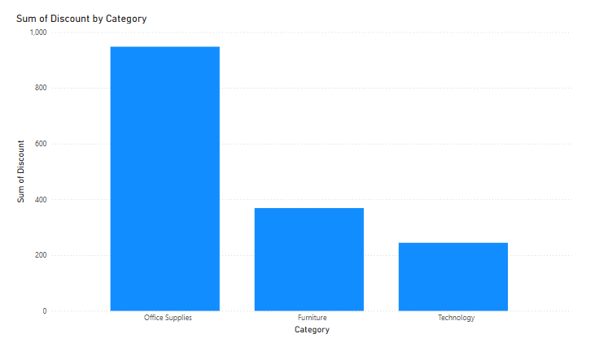

**A Timeline Tale – Sum of Sales by Order Date**

Once upon a time, in the land of commerce, there lived a business that recorded its **sales over time**. The first chart is like a **storyline of their journey**, where each point represents the **sum of sales made on a particular order date**.

In the **beginning (far left)** of the timeline, something magical happened—a huge spike in sales. It was as if the kingdom held a grand festival, and customers rushed in, showering the store with gold (sales). This peak, touching almost **30K in sales**, marks the most prosperous day.

But, as time went on, the magic faded slowly. The line **started descending**, steadily going down with each passing day. There were occasional small bumps, but nothing like that grand beginning. The trend **flattened out**, and the kingdom’s sales stabilized around **6K–8K**, much calmer than the booming start.

This chart tells us: "The business had its **biggest boom early**, then things **settled down** over time."

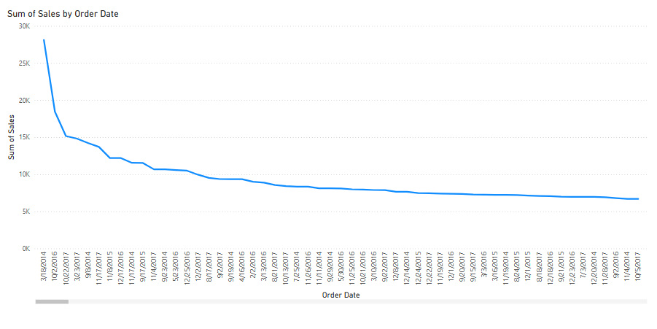

**: The People of the Kingdom – Sales by Segment**

Now, let’s meet the people who made those sales happen.

The second chart is a **donut chart**, and it shows the **3 major customer segments**:

1. **Consumer** – These are everyday shoppers, the heart of the kingdom. They brought in the **most gold: 1.16 million**, which is **more than 50%** of all sales. These are your loyal villagers who kept coming back.
2. **Corporate** – These are business buyers—organizations stocking up. They contributed **0.71 million**, about **30.74%** of the total. Reliable and steady.
3. **Home Office** – The smallest yet significant group. These are folks who work from home and needed supplies. They added **0.43 million**, roughly **18.7%**.

So, in the kingdom of Sales:

* The **Consumers** were the **champions**, driving half the economy.
* The **Corporate** segment was the **strategic ally**.
* The **Home Office** group was the **silent supporter**, smaller but essential.

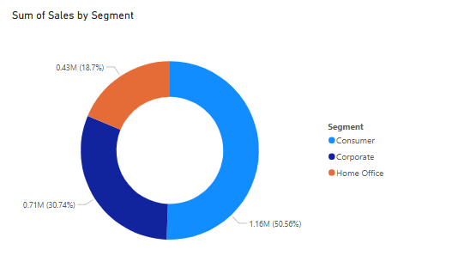

**4. How Each Product Category Performed in Different Regions**

We used a matrix chart to compare how different sub-categories of products performed in each region.

* Some categories like Phones and Chairs did well across many regions.
* But others, like Tables, often caused losses in almost every region.
* This helps the business know which products to push and which ones to review or stop selling.

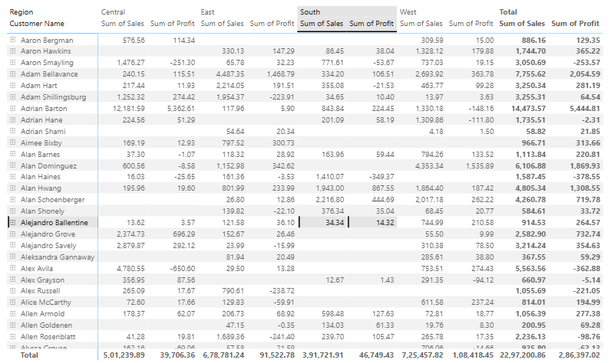

**The Growth Steps – Quantity by Category**

In this chapter, we see a **Waterfall chart** – a magical staircase that shows **how each product category adds up** to the total quantity sold.

**Step 1 – Office Supplies (Green Bar):**  
The journey begins with **Office Supplies**, which takes a **big leap**, adding over **23,000 units** to the total. This category is clearly the **workhorse**, contributing the **largest share** of sold items.

**Step 2 – Furniture:**  
Furniture comes in next, adding a **modest boost** to the total. Not as dramatic as Office Supplies, but still a steady step upward.

**Step 3 – Technology:**  
Finally, **Technology products** add the last jump before the total bar is reached. Though not as big as Office Supplies, it plays a crucial role in reaching the summit.

**The Final Step – Total (Blue Bar):**  
All these steps together build up to a **total quantity of around 38K**. The blue bar at the end shows the **grand sum** of everything sold.

**Moral:** Office Supplies **lead the way**, Furniture and Technology **support the climb**, and together they form a solid mountain of sales.

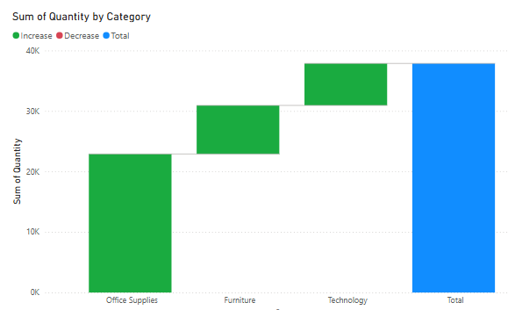

**The Tale of Discounts – By Sub-Category**

Now, let’s meet the characters who gave away the most **discounts** – and how generous they were.

This bar chart reveals which **sub-categories** received the **most discounts**, and the difference is quite dramatic.

**Binders** – The Discount King:  
Binders stand tall, **way above all others**, with a total discount of nearly **600 units**. This sub-category received **the most generosity**, either to drive sales or clear out stock.

**Phones, Furnishings, Chairs, Paper** – The Loyal Nobles:  
These sub-categories got a **healthy chunk of discounts** too, though far below Binders. Each received around **100–150** units of discount.

**Tables, Appliances, Storage, Accessories** – The Middle Class:  
These got **decent discounts**, making them part of the supportive team, but not as favored.

**The Minimalist Sub-Categories – Supplies, Copiers, Fasteners, etc.:**  
These barely touched the discount pool. Their bars are **tiny**, almost insignificant. Perhaps they **sell well without discounts**, or maybe they’re **low-priority items**.

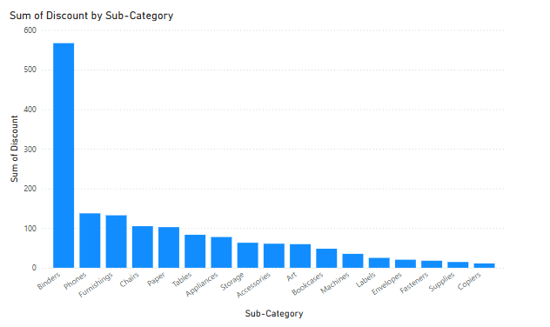

**“Sum of Sales by Region” (Pie Chart)**

This pie chart shows us how sales are distributed across four regions: **West, East, Central, and South**.

* The **West region** leads with the highest sales, contributing to about **31.58%** of the total, which is around **725.46K** in sales. This means customers in the western U.S. are buying more than in any other part.
* The **East region** follows closely behind with **29.55%** of the total sales, contributing approximately **678.78K**. This shows strong performance as well.
* The **Central region** has about **21.82%** of the sales, which is **501.24K**. While this is a decent figure, it’s clearly behind the top two.
* Finally, the **South region** has the lowest contribution with just **17.05%** of the total sales, which is **391.72K**. This might indicate lower demand or less store presence in that region.

**What does this tell us?**  
The business is doing best in the **West and East regions**, while the **South region** might need attention. The company could explore marketing or logistics improvements in the South to boost performance.

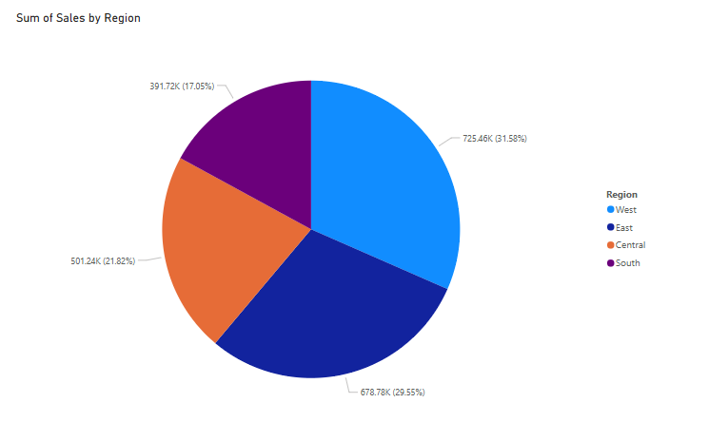

**“Sum of Sales by Ship Mode” (Bar Chart)**

This bar chart displays how much sales each shipping method has generated.

* The **Standard Class** shipping method is used the most, with over **1.3 million** in total sales. This shows that most customers are comfortable with regular delivery times and probably prefer lower shipping costs.
* **Second Class** and **First Class** follow with around **400K** and **300K** in sales respectively. These are moderate, and show that some customers are willing to pay a bit more for faster delivery.
* **Same Day** shipping has the least amount of sales, with under **200K**. This suggests that very few customers are opting for immediate delivery, probably due to the higher cost.

**What does this tell us?**  
The majority of customers prefer the **Standard Class** shipping — it’s affordable and reliable. Faster shipping options are used less often, which means the business should focus on making standard delivery even more efficient, while possibly promoting express options where needed.

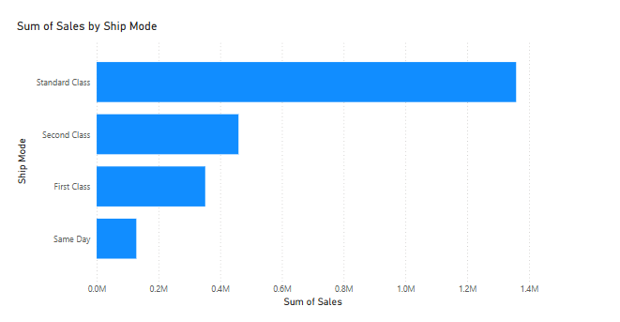

**The Geography of Sales – Quantity by State**

This is a **Line Area Chart** showing the **total quantity of products sold**, broken down by each **U.S. state**.

**Top Performers:**

* **California** is **way ahead of everyone** with a quantity near **8,000 units**.
* **New York** and **Texas** follow, but they are **far behind California**, sitting somewhere around **4,000** and **2,500** units respectively.

These three states form the **"Power Trio"** in terms of sales quantity. They have the **highest customer base or demand**.

**Gradual Decline:**

* After the top 3, the chart shows a **sharp drop**.
* States like **Pennsylvania, Washington, Illinois, Ohio, Florida** perform decently but are not in the top tier.

**Low Performers:**

* Toward the right side of the chart, we see states like:
  + **Wyoming**
  + **West Virginia**
  + **North Dakota**
  + **South Dakota**
  + **Montana**
  + **Vermont**

These states have **very low quantities sold**, barely touching the graph. This could be due to:

* Lower population
* Less demand
* Limited marketing reach
* Fewer physical stores or delivery options

**Insights:**

* **California is the clear sales engine** – probably due to its large population and strong economy.
* The sales trend follows the **Pareto Principle (80/20 rule)** – a few states (top 20%) contribute to most of the quantity (80%).
* There’s a **huge gap** between the top states and the rest, which could be an opportunity for **targeted growth strategies** in underperforming areas.

